Big Data Lab04

Group members: Liang Haoxuan, Liu Sihan, Wang Changpeng

Basic Tasks

1/ MongoDB links documents together in a collection relationship, and there some key ways MongoDB handles relationships: ****Embedded Documents & References****

2/ In MongoDB, the database is a collection, like a table in Relational Database. And the Data is stored as a json, so it doesn't need to create a excat table before insert the data. In this example, the db.customs. insertOne method is used to insert a document into the customers collection, which contains custId, contact, and loan.

3/ In MongoDB, documents with different fields can be inserted into a collection at any time, making the database design very flexible and able to easily adapt to changes in applications.

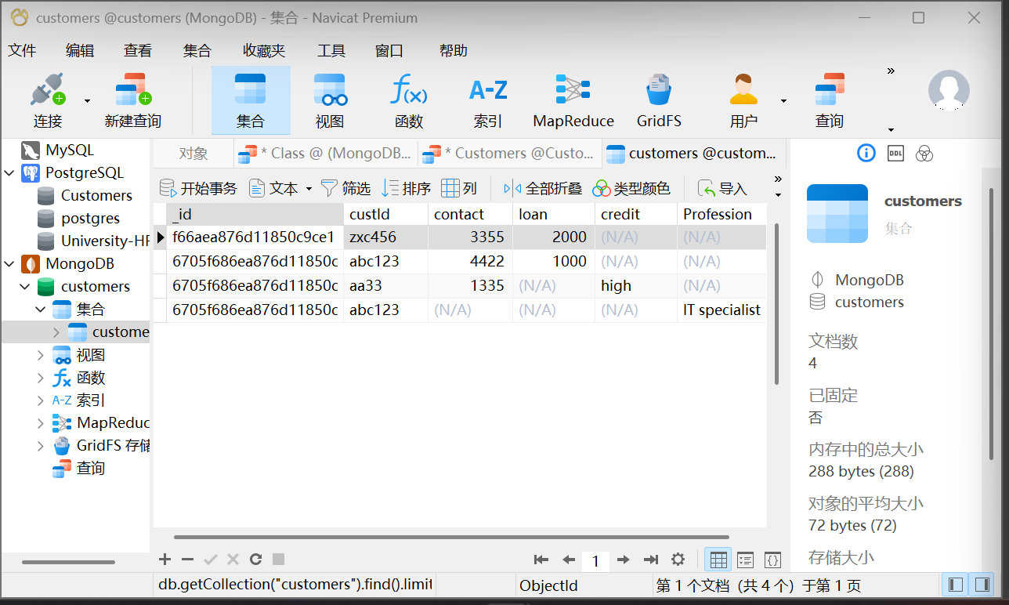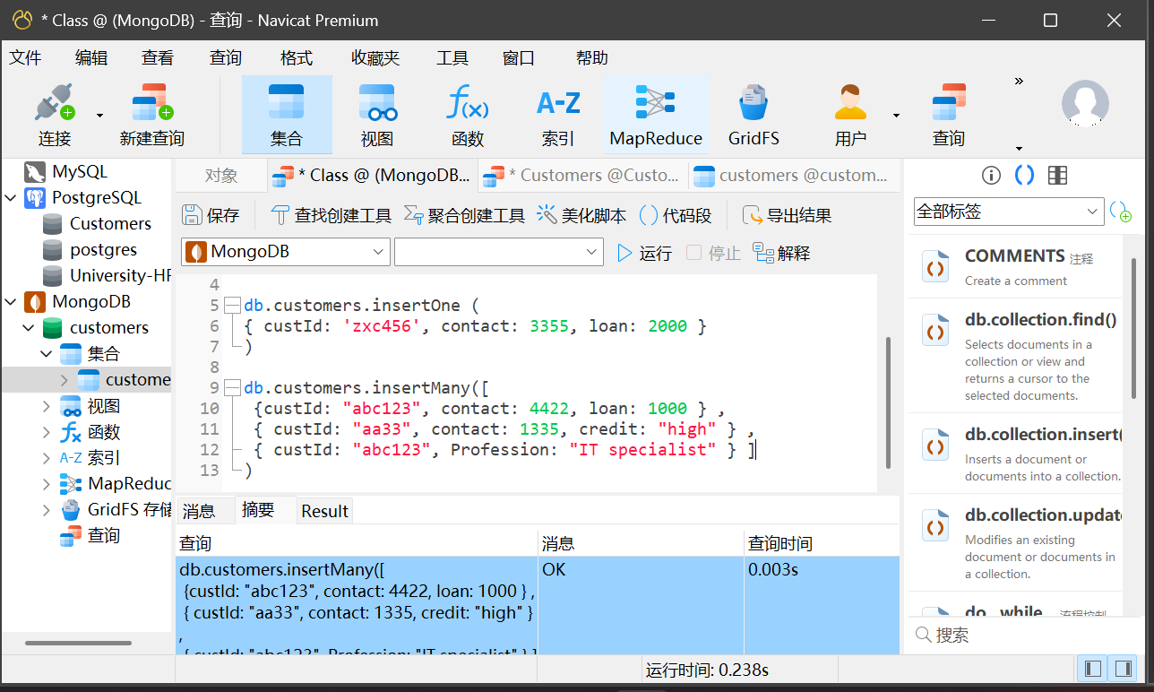

Medium Tasks

4/ a/

db.employee.insertMany([

{empNo:'E55',lastName:'Carmen',firstName:'Silva',hours:450,gender:'F'},

{empNo:'E44',lastName:'Ryad',firstName:'Patel',hours:380,gender:'M'},

{empNo:'E66',lastName:'Susan',firstName:'Joyner',hours:350,gender:'F'},

{empNo:'E77',lastName:'Waiman',firstName:'Zhu',hours:400,gender:'M'}

]

)

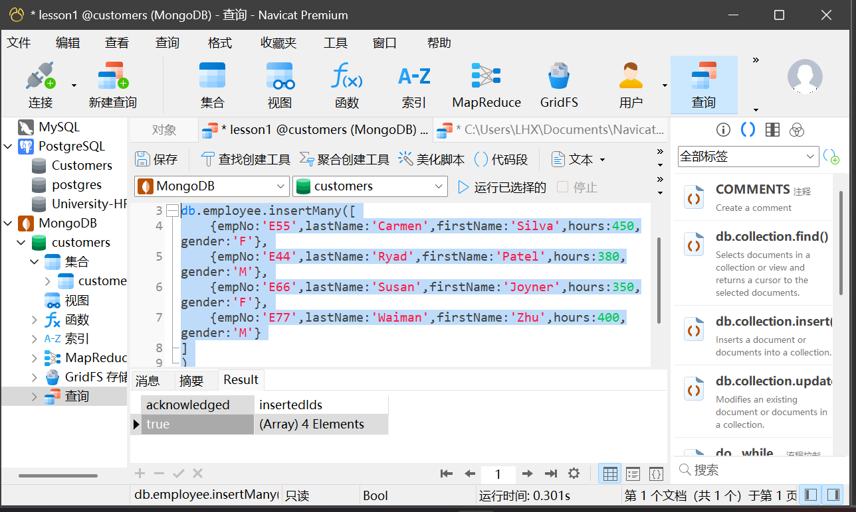

b/

Advanced Tasks